**Web Application Requirements**

Tianming Xu, Alex Mathew

Group 8

**Description:**

Personal fitness web application, this website is a place to get a personalized fitness training program according to their body situations and full set information of how to become healthier.

**Purpose:**

This web application is used to personalize the fitness training program for specific users and detailed purposes, provide courses and advises for user to learn how to perform right movements during the training and other information related to fitness and health.

**Marketing:**

Advertising in fitness center, gym with sports stars and other health people that use our website to show potential user our program results, benefits and advantages.

**Target Audience:**

Every one

**Competition / Examples:**

Zen planner, Mindbody, Fitbit Start

**Technical Requirements:**

Server type: Virtual

Hypervisor: Oracle VM VirtualBox

Web Server: Apache

Database: MongoDB

Scripting Language: PHP

Support Libraries: Not Decided yet

Framework: Laravel

Access to server: Linux Shell

Access to database:NoSQL Viewer and Mongo db Shell

Security / Authentication: Password & Salt and may be token to authenticate user and web security scanner (maybe) to prevent malicious attack.

**Diagram:**

**Web App Architecture:**

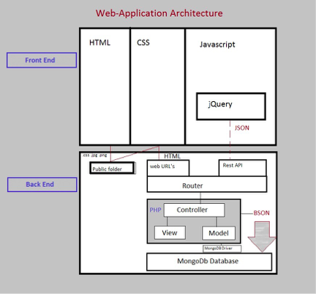

**User flow Diagrams:**

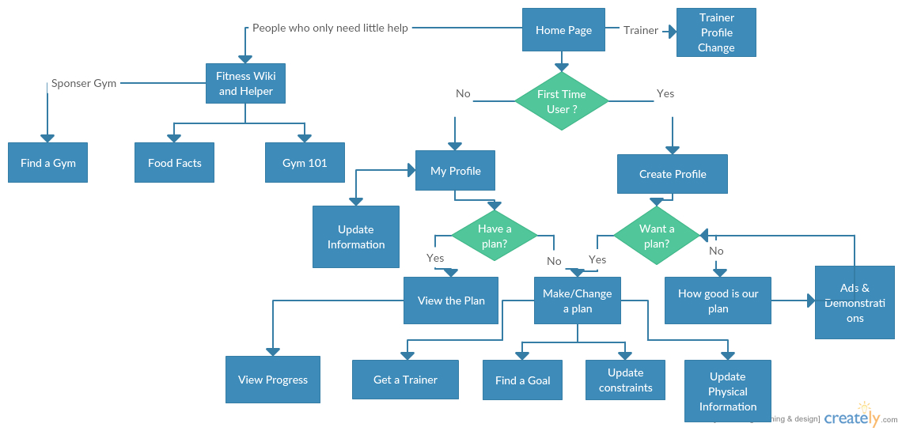

**Sitemap:**

Homepage:

Homepage

showcases, brief information about the services

Services:

Make a personal profile /My Profile:

Login and credential page

User basic and physical information page

Get fitness plan / Modify food plan:

Basic Plan

Advanced Plan

Food plan/ Modify food plan:

Facts:

Food Nutrition Chart

Workout Tutorial

Support

Contact a local trainer/fitness center

About Us:

Contact information

Staff / Partner information

Pricing

Probably: Trainer’s Profile

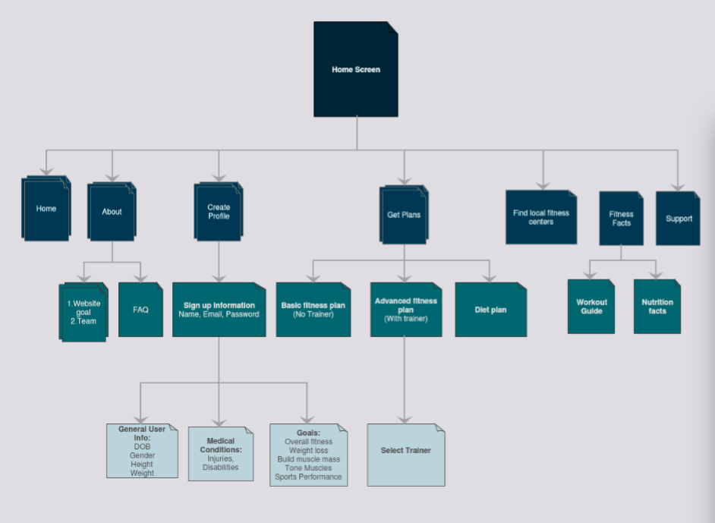

**Database Design:**

Since our database is highly personalized and customer based, we use No-sql database instead to reduce the cost of adding new attributes.

Our database has three major parts, one is personal information related to different customers User. Another is basic immutable facts, like price, food, training information. Last one is partner information which will also be immutable in this case because most of them are just fake.

Here is the possible user information in the USER list:

**USER: User ID, Username, Email, Authentication, Contact, DOB, Gender, Height, Weight, Disability: [ ] , Goal: [ ], Injury: [ ], Body Fat Percentage: [ ], Fitness Plan; and etc.**

Since different users may have or may not have certain fields in the list, I only list some necessary and most common fields in the list.

Because we create the plan from user’s specific detailed information and suggestions from professional trainer, different plans in PLAN list may have or may not have certain fields in the list, I only list some necessary and most common fields in the list.

**PLAN: Plan ID, Plan name, Plan Type, Plan Goal, Plan Impact, User Info: [ ], Schedule: [ ], Trainer Info: [ ], Workouts: [ ], Food: [ ], Forbidden Food: [ ], Diet Program: [ ], Gym, Progress, and etc**

Facts contain four lists:

**FOOD: Food ID, Food name, Protein Per, Sugar Per, Fiber Per, and etc.**

**Just some normal nutrition facts.**

**WORKOUT: Movement ID, Movement Name, Movement Type, Focus Area, Consumption per minute: [ ], Suggested sets, Workout Guide, Workout Guide Video Address: [ ], contributer, and etc**

**GYM: Gym ID, Gym Name, Gym Location: [ ], Gym price: [ ], Gym photo, Gym facilities: [ ], Gym Trainer: [ ], Open Hour and etc.**

**TRAINER: Trainer ID, Username, Email, Auth, Contact, Gym, DOB, Gender, Height, Weight, Trainee: [ ], Body Fat Percentage: [ ], Awards, Locations, Prices, ; and etc.**

*All the lists (tables) may have different fields. although the Facts part may not change too much.